1. Sprint 2: Review

1.1 Scope and Outcome
Duration: 5 hours. Scope: 31 story points; 27 from five new backlog items (C1, C5, U5, U6, U7) plus 4 carried over from Sprint 1 (C2, C4).
Priority | Card | SP
Carry-over (Must) | C2: Clear per-module data-failure messages | 3
Carry-over (Should) | C4: Visible version string | 1
Should have | C1: In-app help panel | 3
Should have | C5: Provider diagnostics | 5
Should have | U5: Consolidated news & macro feed | 3
Must have | U6: Portfolio exposure & risk overview | 8
Should have | U7: P&L strategy modelling | 8

Outcome: all 31 story points reached development completion within the time box and moved to Testing the first sprint in this project to fully burn down. C2, C4 and U6 were completed by 12:45. Between 12:45 and 2:00, the rest of the team paused and Hossein continued alone, completing C5. From 2:00 to 3:30, the full team resumed and completed the remaining items C1, U5 and U7.

1.2 Why Sprint 2 Finished Faster Despite More Story Points
Sprint 1 carried 29 story points in a 3-hour window but bottlenecked on a single backend developer working in the team's first sprint together. Sprint 2 carried a nominally larger scope, 31 story points, and nonetheless completed within its time box. Four concrete changes explain the shift. First, capacity was restored: both frontend developers were present alongside backend, so frontend and backend work ran in parallel instead of queuing behind one person. Second, the time box itself was longer, five hours against three, which gave the team enough margin to absorb the mid-sprint dip in capacity between 12:45 and 14:00, when only Hossein continued working alone on C5. Third, task complexity was lower: Sprint 2's items, an in-app help panel, provider diagnostics, a consolidated news feed, portfolio risk overview, and P&L modelling, built on the API integrations and design tokens already delivered in Sprint 1, rather than introducing new external dependencies, so each story point required comparatively less investigative and integration effort to clear. Fourth, the team was no longer new to itself: card sizing, board conventions, and frontend-backend handoffs were already established from Sprint 1, which reduced the coordination overhead that a first sprint necessarily carries. The net effect was not that Sprint 2 was a smaller undertaking, it was in fact larger by story-point count, but that team capacity, schedule length, and task difficulty were all better matched to the work than they had been in Sprint 1.

1.3 Burndown
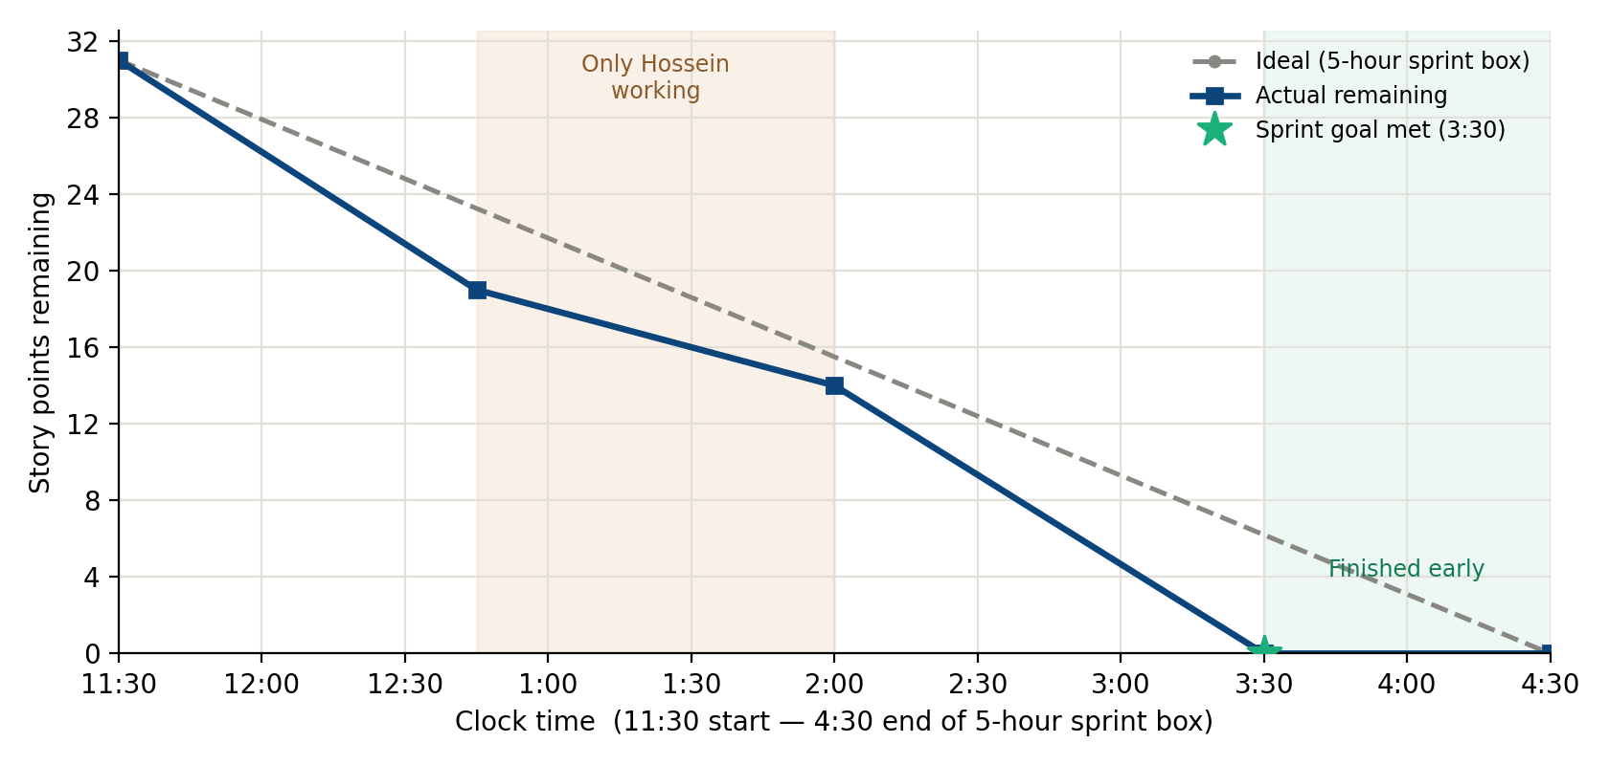
Figure 2. Sprint 2 actual burndown against a time-proportional ideal, 11:30–15:30. The shaded band marks the 12:45–14:00 window in which only Hossein continued working.

2. Current Board Status
As of this report, no cards have reached Done. All 16 cards completed across Sprint 1 and Sprint 2; 56 story points in total sit in the Testing column awaiting peer verification, per the board's rule that verification must be performed by someone other than the card's author.
This is the most significant open risk in the project: development velocity has been strong across both sprints, but the verification stage has not yet been exercised at all. Sprint 3 must treat closing this gap as a first-class deliverable, not a formality.

